Bring Back One Better Service
EP051 review draft | October 26, 2026 | Not yet approved for companion publication
The question is not whether your organization can produce an answer faster with AI.
The better question is whether the person receiving that answer can finish what they came to do.
A correct instruction can still lead to a locked door. A friendly response can still send someone around the same loop. A closed ticket can still leave the work unfinished.
That is the operating idea behind AI Change Desk Episode 51, What Changes After the Conference?
I attended Gartner IT Symposium/Xpo in Orlando last week. The connection I brought home was not another platform category. It was the relationship between attention, practice, and evidence of improvement. These are my reflections on the sessions in my notes, not a survey of attendees or a claim about what every peer believes.

The work continues after the response
Consider an invented support request. An employee cannot sign in to the system needed for a time-sensitive task. The assistant immediately supplies the correct knowledge article. Following it requires signing in to that same system.
The answer is accurate. The person is still stuck.
If the success measure ends at response delivery, the dashboard can improve while the recipient's experience deteriorates. Someone else absorbs the correction, the repeated explanation, or the trip to another queue. That work does not disappear because it happens outside the reporting window.
An answer is an output. Resolution is a result for a person.
The distinction changes where we look. Instead of asking only whether the response used an approved source, ask whether the recipient could use it, correct a misunderstanding, and reach someone when the normal route failed.
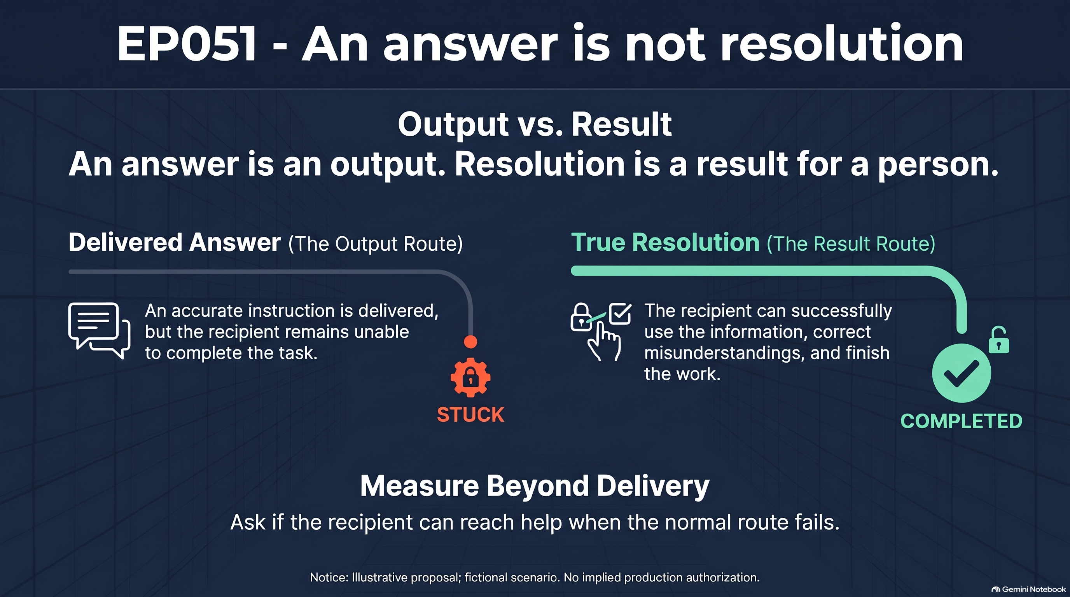
An answer is an output. Resolution is a result for a person.

What the conference signals do and do not establish
Gartner's October 19 keynote release argues for coordinating AI value and risk rather than managing them as separate conversations. I take a practical lesson from that: the service owner, the person responsible for information boundaries, and the person funding the work should evaluate the same proposed change. That application is mine, not a claim that a new committee guarantees better outcomes. Gartner keynote release
A separate October 19 release reports that 13% of CIOs said their enterprise had achieved significant or transformational value from AI. Gartner describes a survey of 2,002 CIOs and technology executives conducted from May through July 2026. This is attributed self-report, not an independent audit, and it does not mean everyone else received no benefit. It makes a useful question harder to avoid: what changed enough to matter? Gartner survey and methodology
Gartner's October 20 trends release includes AI context platforms and AI agent identity. For a service owner, those themes prompt two distinct questions: which information should inform this task, and what actions may the system take? They are not instructions to buy another product. Gartner technology trends
These pages are one source family, not three independent confirmations. Treat them as signals for examination, not proof that a particular design will work in your organization.

The five checks before a service trial
Use these checks to prepare a proposal. They are not a validated assessment, compliance certification, or permission to alter a production system.

1 Define the task
Question: What must the recipient be able to complete?
Evidence: One plain-language outcome, the current route, and a fictional example that includes an unsuccessful attempt. For the access request, the outcome is completing the permitted task, not merely receiving instructions.
Failure mode: The team defines success around something its tool can easily count, such as a response or an automatically closed ticket.
Decision rule: If the outcome cannot be described without naming the AI product, return to the problem definition. Also identify who may be unable to use the preferred digital route; do not assume that silence means success.

2 Account for the whole effort
Question: Where does the work go after the first answer?
Evidence: A route map showing handoffs, return visits, corrections, and human effort. Include the person who quietly repairs the response after the official process declares completion.
Failure mode: A faster front door transfers effort to the recipient or another team, making a local improvement look like a complete service improvement.
Decision rule: Do not call the proposal an efficiency gain if its evaluation excludes the people who inherit the work. Compare like tasks and preserve exceptions rather than averaging them out of sight.

3 Give practice an owner and time
Question: How will employees learn to recognize a convincing but unsupported answer?
Evidence: Protected practice time, a named coach, an invented incomplete request, usable feedback, and a second attempt. Record which existing work will pause to create that capacity.
Failure mode: The organization announces a learning program but funds it with employees' evenings. The most attentive person becomes the permanent repair service.
Decision rule: If there is no capacity to practice and no person available to help, reduce the trial's scope or delay it. Attendance at a presentation is not evidence that someone can handle the difficult case.

4 Separate attention from intrusion
Question: What information and authority does this specific interaction require?
Evidence: A permitted-information list, a clear distinction between drafting and acting, and a human route for situations outside scope. Write what the system must not collect, infer, change, or send.
Failure mode: Personalization becomes a reason to gather extra details, or a drafting assistant acquires account-changing authority without a separate decision.
Decision rule: Test with invented material first. Keep a proposal on paper until the appropriate owners approve its actual tools, data, and permissions. A person can feel heard without being profiled.

5 Decide what evidence will change the plan
Question: What would make us continue, revise, or stop?
Evidence: A comparison, a review date, a decision owner, and evidence from recipients as well as builders. Include task completion, repeated requests, correction effort, and access to human help.
Failure mode: The easiest example becomes the success story, while awkward cases are labeled unusual and moved outside the report.
Decision rule: If the team cannot identify evidence that would change its decision, it has a demonstration plan, not a learning plan. A few invented cases can expose a flaw; they cannot establish population-wide effectiveness.
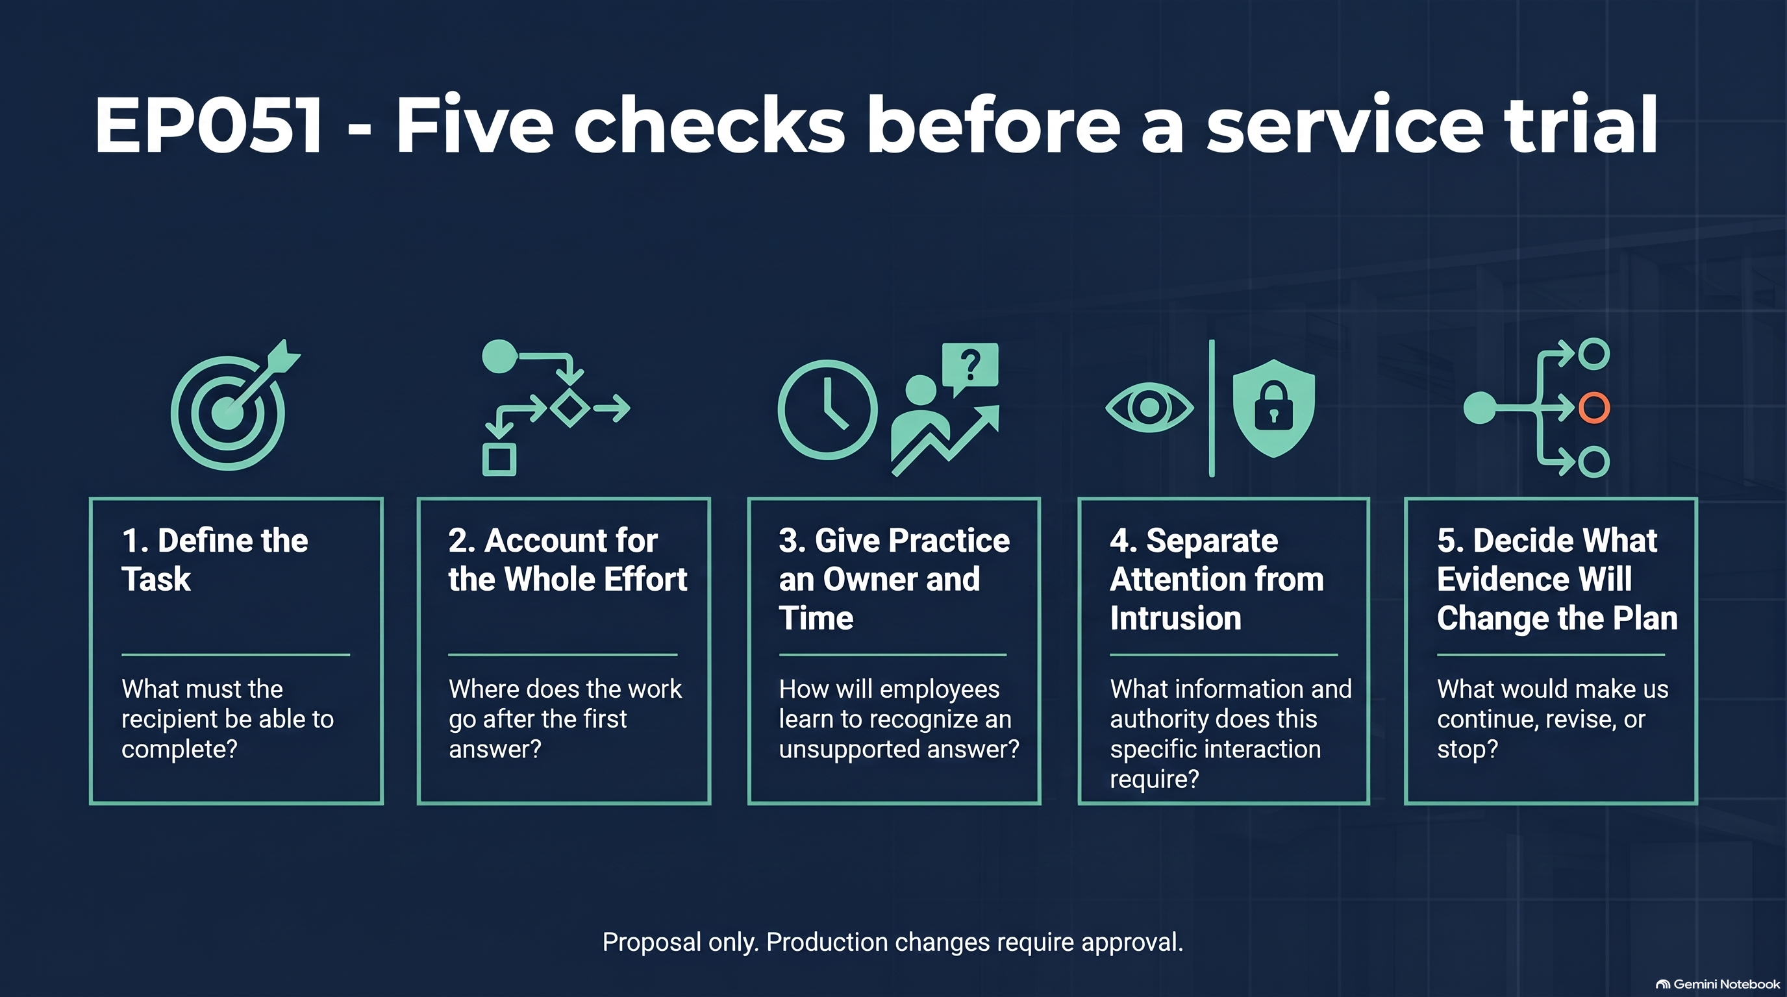
Define the task, count the whole effort, resource practice, preserve boundaries, and decide what evidence changes the plan.

A week that looks better on the dashboard
This is a fictional scenario, not a report about a named organization.
Monday: A support team starts an AI-assisted draft workflow. First responses arrive faster, so the team tracks response time as its main outcome.
Tuesday: Staff begin closing requests after sending the recommended article. No one has agreed what counts as actual resolution.
Wednesday: An employee cannot follow an instruction because it requires the access they are trying to restore. They open another request and repeat the explanation.
Thursday: A colleague repairs the response through a side conversation. That work is absent from the report.
Friday: Leadership sees shorter response times. The team has evidence of faster answers but not of improved resolution.
Nobody needed to behave maliciously. The measurement stopped before the person's problem did.
Now replay the week with the five checks.
On Monday, the owner defines completion from the recipient's task and rehearses an invented blocked-access case. On Tuesday, staff practice recognizing when the normal instruction is unusable. A coach has protected time, not just an invitation to be helpful.
On Wednesday, the exception route brings the request to an authorized person without widening the assistant's permissions. On Thursday, the team records correction effort and repeat contact alongside response time. On Friday, the owner reviews both the useful cases and the failures before deciding whether to revise the workflow.
That is a better decision process. It is not a promised improvement percentage, and it does not establish that the system is ready to scale.
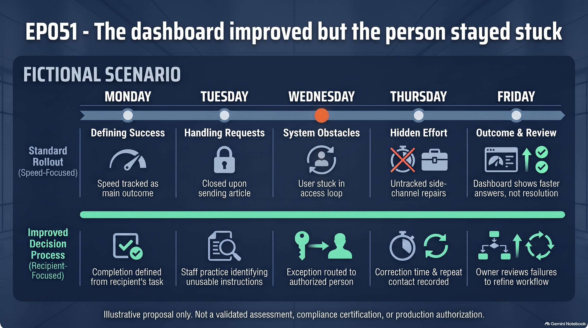
A fictional service week shows why faster first responses do not establish improved resolution.

Use forty five minutes on one interaction
Invite someone who does the work, the service owner, and someone responsible for the information boundaries. Bring an invented request. Keep the exercise on paper; do not connect a real system or paste an employee's case into an unapproved tool.
The episode uses four blocks of 10, 10, 10, and 15 minutes. This article breaks the same work into five facilitation steps so the information boundary gets an explicit check.
- Minute 0-8: Describe the person, the task, and what successful help means. Do not name an AI product yet.
- Minute 8-18: Map the route to actual resolution. Include returns, corrections, waiting, and the person doing invisible repair work.
- Minute 18-28: Try one change on paper. It may be a better instruction, a human escalation route, ordinary automation, or an AI-assisted draft. Name what must improve and what must not worsen.
- Minute 28-36: Check permitted information, action authority, and the human fallback. Assign a coach and identify the work that will pause to make practice possible.
- Minute 36-45: Write the proposal, comparison, review date, and decision owner. Send it through the approvals applicable to the actual system and data before any real-world trial.
The output is one page: the person's need, the proposed change, the support provided, the boundary preserved, and the outcome to check.
If the page contains only a product name and an optimistic arrow, keep working.

Track the result for one month
After any separately authorized trial begins, review these measures weekly for four weeks. Define the sample, observation period, and comparison before interpreting movement.
- Task completion: How many people completed the intended task? Show the denominator and the cases with no confirmed outcome.
- Return effort: How many requests reopened or required the person to explain the problem again?
- Correction burden: How much human time went into fixing or clarifying the output, including work outside the original queue?
- Human help: Could the recipient reach the promised person, and how long did that take?
- Practice delivered: Did the scheduled practice and coaching actually happen? Which difficult example changed the design?
- Boundary exceptions: What attempted information collection or action fell outside the agreed scope, and how was it handled?
Use the minimum necessary information through approved processes. Do not build a new surveillance program to prove that the service is considerate. Report what the sample cannot establish; small numbers and changing case mix can make a comparison misleading.
Ask the recipient a plain question: did this help you finish, or did it give you another task?
Then ask the owner a different one: what will you change because of the answer?

Bring back a change someone can feel
Make the work better for someone. Then check whether you did.
Listen to Episode 51
Watch Episode 51 on YouTube

Disclosure
AI-assisted tools supported research and production. Final editorial judgment, risk posture, and release approval remain human-led. This is operational guidance, not legal advice. The exercise and scenario are illustrative, not validated assessments or claims about an employer. My current role includes privacy work, which informs my attention to purpose, access, retention, deletion, and accountability. I do not discuss nonpublic work here. These are my personal views and do not represent the State of Oregon or any other organization.

