The Report Was Independent. Was Your Decision?
The launch slide says an independent expert reviewed the assistant.
The report says the expert examined a narrow test, could not inspect part of the evidence, and recommended another check before customer use.
Both sentences fit on a page.
Only one of them tells the person running the launch what they need to know.
The question is not whether an expert was involved. The better question is whether the expert's actual finding survived the trip into the decision.
That is the operating idea behind AI Change Desk episode 47, Who Checks the AI Safety Claim? This field guide gives you a practical way to follow one recommendation into the work without pretending a review creates authority or evidence that does not exist.

The claim gets broader as it travels
A technical team evaluates one configuration, one data set, and one permitted use. A reviewer identifies limitations. A sponsor summarizes the result. Procurement wants a short answer. An operator wants to know whether Monday's launch is still happening.
At each handoff, a little context can disappear.
Tested on synthetic accounts becomes tested with customer data. Reviewed for drafting becomes approved for sending. A recommendation becomes a footnote. A footnote becomes a green status.
Nobody has to intend deception for the final sentence to become less true.
The repair is not a longer slide deck. It is a decision record that keeps the claim, the limits, the finding, the responding authority, and the resulting work together.

Why this matters now
On September 22, OpenAI proposed principles for third-party technical safety assessments, emphasizing defined claims, access, methods, and actionable findings. It describes much of that work as longer-term rather than tied to individual launches. This is a proposal for scrutiny, not evidence that a particular deployment has been certified. OpenAI assessment principles.
Microsoft's September 24 run-assert-eval example follows a billing-agent finding through a runtime control and retest. Reported violations declined, but failures remained in parts of the test. The article describes a repeatable release gate as future work. A worked example is useful evidence about a method; it is not an independent guarantee for your environment. Microsoft worked example.
On September 28, Australian minister Katy Gallagher said Services Australia had redirected a reporting inbox to a cyber centre staffed around the clock, while investigations continued. That is an attributed process change, not independent proof of a resolved incident. It does identify something concrete an assessor could test. Official interview transcript.
These sources address different situations. Treat them as signals, not proof that a particular deployment is safe. They do not corroborate one another's technical results. Together, they sharpen an operating question: after somebody finds a problem, what changes?
The existence of an independent review is not evidence that every proposed use is safe.

Keep three claims separate
We changed a control.
We tested that control.
We verified a particular outcome.
Those are different statements with different evidence requirements.
A configuration change can establish that a setting changed. A controlled test can establish what happened under specified conditions. A verified outcome needs evidence tied to the outcome being claimed.
One does not automatically establish the next.
Before using the word safe, ask which statement you can actually support and what remains outside it. If the evidence supports only a small internal exercise, do not let the launch summary turn that into permission for unrestricted customer use.
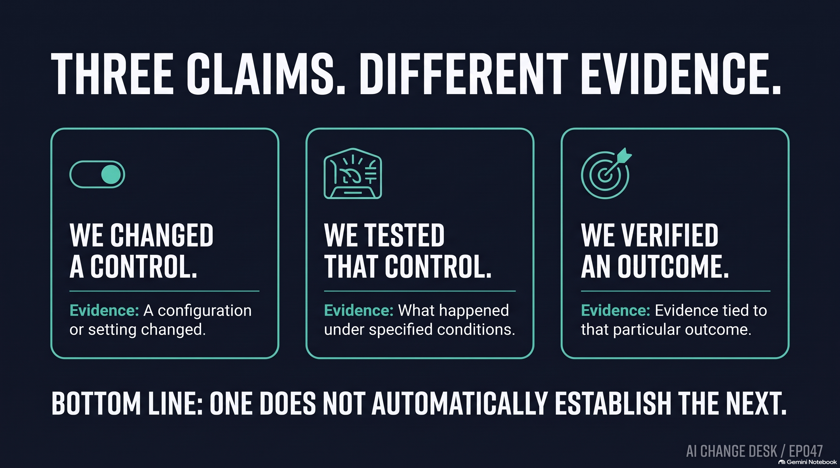
NotebookLM infographic 1: EP047 - Three claims, three evidence requirements

Run the Recommendation-to-Decision Check
Choose one consequential recommendation. Use five entries, not a new collection of sensitive logs. Point to controlled evidence where it already lives.

1. Decision: name the use being considered
Ask: what exact action is someone being asked to permit?
Evidence: a versioned description of the system, configuration, audience, data boundary, intended action, and decision deadline.
Failure mode: approval to continue a synthetic exercise quietly becomes approval to serve customers.
Decision rule: if the reviewer and the person approving the work cannot describe the same proposed use, stop summarizing the result and resolve the scope first.
Useful language: "This decision concerns draft-only replies for an internal training group using synthetic accounts. Customer use is outside this decision."

2. Evidence: retain what was examined and excluded
Ask: what did the reviewer actually see, and which relevant conditions were not examined?
Evidence: the report reference, test conditions, configuration, access limitations, unresolved questions, test provider, and person or organization that ran the test.
Failure mode: a familiar institution's name becomes a substitute for reading the scope of its work.
Decision rule: a conclusion cannot become broader merely because it moved into a shorter document. Put the material exclusion beside the recommendation, not in an attachment nobody opens.
Use synthetic examples where they answer the question. Where they do not, have the appropriate owners decide what relevant evidence may be shared, with whom, under which controls, and for how long. Outside expertise is not permission to export every customer record or credential.

3. Recommendation: preserve the finding
Ask: what response did the reviewer actually recommend?
Evidence: the original finding, proposed response, uncertainty, and any unresolved disagreement.
Failure mode: "proceed after testing the conflicting policies" becomes "proceed."
Decision rule: keep the condition attached. If the reviewer disagrees with your summary, preserve the disagreement and correct factual mistakes. Do not convert silence into agreement.
Useful language: "The reviewer recommends delaying customer use until the policy-conflict test is complete. The finding remains open."

4. Authority: assign the answer
Ask: who can respond to this finding, and what are they actually allowed to decide?
Evidence: the named role, relevant authority, permitted escalation or exception path, and a recorded disposition with reasons.
Failure mode: the expert, sponsor, and operator each assume somebody else can resolve the issue.
Decision rule: expertise, budget ownership, and access to the launch button are not interchangeable forms of authority. If the required authority is absent, escalate; this worksheet cannot manufacture it.
An organization may require an unresolved finding to block release. It may permit a narrower use under specified conditions. Those choices must come from the organization's actual rules, not from a convenient interpretation invented during the meeting.
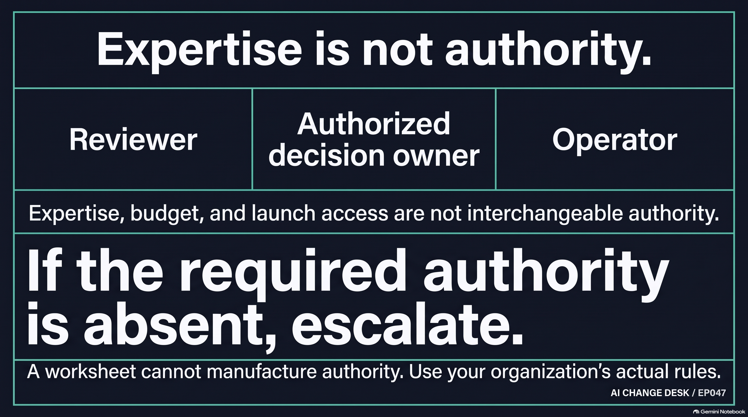
NotebookLM infographic 2: EP047 - Expertise is not decision authority

5. Work: make the response executable
Ask: which instruction, limit, task, or launch decision changes, and who verifies it?
Evidence: an assigned implementation action, due date, check or retest, and trigger that reopens the decision.
Failure mode: the committee records a careful response while the original launch plan remains untouched.
Decision rule: the operator should be able to explain what they will do differently. If they cannot, the response has not reached the work.
Useful language: "The launch owner removes customer access, the test owner completes the conflicting-policy cases, and the decision owner reconvenes before any expansion."
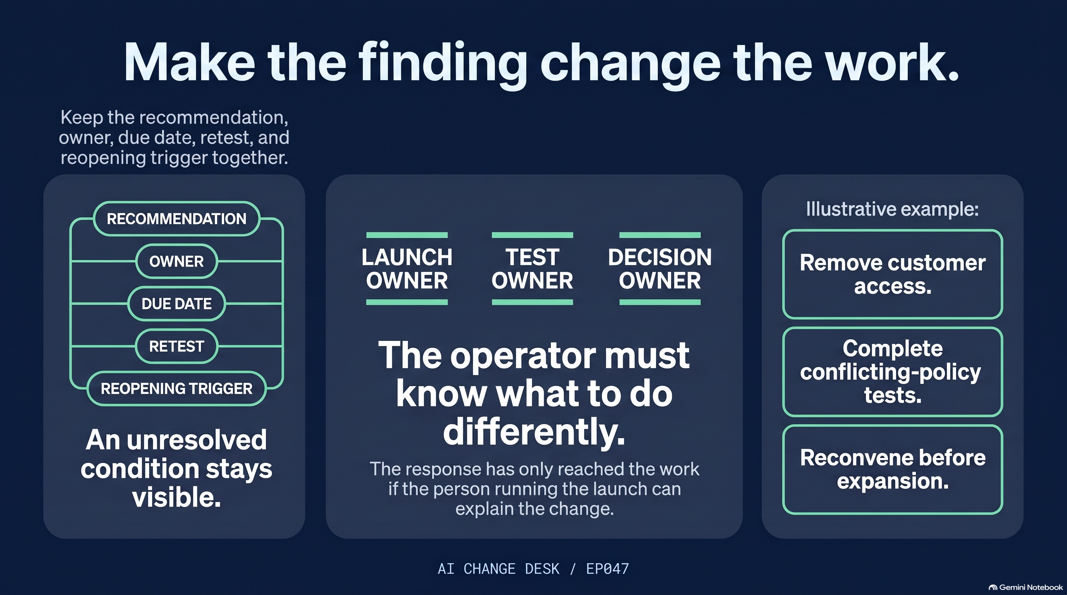
NotebookLM infographic 3: EP047 - Make the finding change the work

A realistic scenario: replay the week
Consider an invented support team preparing an assistant that drafts replies.
Monday: the team runs a small exercise using synthetic accounts.
Tuesday: an internal sponsor asks whether it can handle real customer questions next week.
Wednesday: the reviewer notices that conflicting policy documents were not tested.
Thursday: the launch slide says the assistant has been independently reviewed.
Friday: the operator asks whether to enable customer access.
Without a bounded decision, each person can answer a different question and still believe the team agrees.
Now replay Thursday with the check. The reviewer preserves the missing test. The proper owner either delays, requests more evidence, or considers a narrower permitted exercise. The operator receives the actual limit. A date and trigger bring the issue back.
No one claims the reviewer approved customer use. No one mistakes a meeting for an implemented control. The difference is not more ceremony; it is less ambiguity at the point where work changes.

A 45-minute practical check
Pick one proposed use, one real recommendation, and the person who can answer it. If the reviewer cannot join, name someone to verify your interpretation afterward; a role-play is not their agreement.
• Minutes 0-7: write one decision sentence. Name the version, audience, action, and limit.
• Minutes 7-15: record the evidence examined and excluded. Give unknowns an owner and date.
• Minutes 15-23: state the recommendation precisely. Establish who may respond and whether another authority is required.
• Minutes 23-33: record the permitted disposition, reason, and unresolved condition without rewriting the finding.
• Minutes 33-40: trace the response into an actual work instruction, launch limit, or test assignment.
• Minutes 40-45: name the reopening trigger and read all five answers aloud.
The session succeeds when you have one bounded decision and an executable response, or a clearly owned gap that prevents a premature decision. It cannot create missing evidence, establish compliance, or grant an exception power.

The scorecard: measure the handoff, not the meeting count
For one month, track a small set of observations:
• Recommendations awaiting a named, authorized response.
• Decisions with a clear scope and visible evidence limitations.
• Material recommendations summarized inaccurately and subsequently corrected.
• Promised work changes with implementation and retest evidence.
• Open conditions that reached their review date without a disposition.
Add one operator question: "Can you explain what this review changed about the work you are permitted to do?"
These are proposed management measures, not validated safety scores. Do not combine them into a reassuring percentage that hides the most consequential unresolved finding.
The point is to notice where a recommendation stops moving.

Before the next launch
Ask for the finding, not just the institution's name.
Ask for the answer, not just attendance at the meeting.
Ask for the changed work, not just the approved minutes.
The episode explores the human side of that gap: a reviewer with expertise, a sponsor with a budget, and an operator with a launch button. This check gives them a shared decision instead of three private assumptions.
Expert advice deserves an answer. The person making the decision still needs to own it.

Listen and put the check to work
Listen to AI Change Desk episode 47, Who Checks the AI Safety Claim?, for the decision that follows the safety finding: who can change the work, and what happens if nobody answers?
Listen to the episode
Episode page, transcript, and sources
Download the Recommendation-to-Decision worksheet
Editorial draft checked September 28, 2026. AI-assisted tools supported research and production; final editorial judgment and approval remain human-led. This is operational guidance, not legal advice. These are Michael's views, not those of any employer or organization.

