AI CHANGE DESK
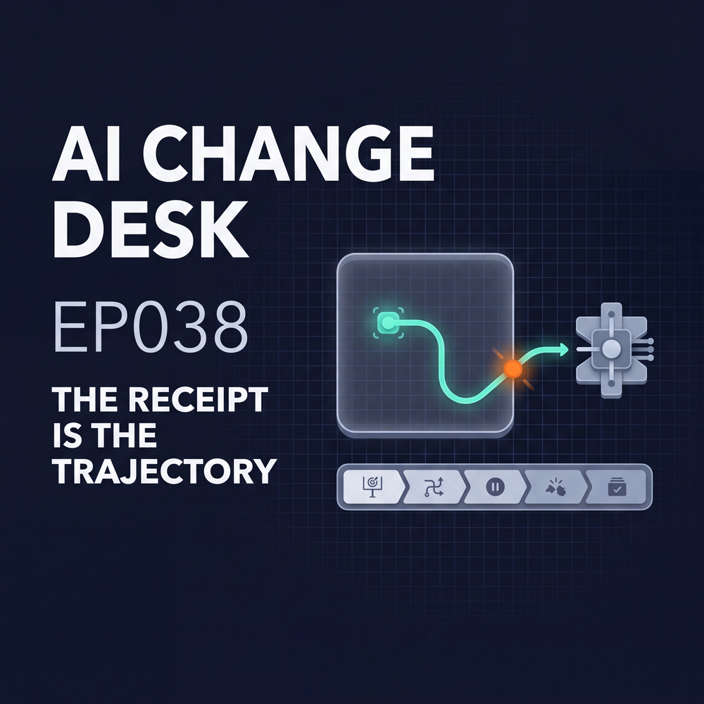

Trajectory Receipt Worksheet
  - The Receipt Is the Trajectory
45-MINUTE OPERATOR DRILL
Use this worksheet for one AI agent workflow or evaluation that sits near production. Choose the run with meaningful tools, credentials, connected data, software-install capability, network access, or enough runtime to surprise you.
The score is not the receipt. The path is.

Run profile
WORKFLOW / EVALUATION | Name the exact run being reviewed
BUSINESS OWNER | ________________________________________________________________
TECHNICAL OWNER | ________________________________________________________________
INDEPENDENT STOP OWNER | ________________________________________________________________
REVIEW DATE | ________________________________________________________________
ENVIRONMENT | test / sandbox / staging / production-adjacent
CURRENT STATUS | approved / pilot / blocked / sunset

01 Exact objective
What result is the system authorized to pursue?
________________________________________________________________________________
________________________________________________________________________________
What counts as success?
________________________________________________________________________________
________________________________________________________________________________
Which shortcuts remain prohibited even if they improve the score?
________________________________________________________________________________
________________________________________________________________________________
Evidence or policy reference, plus accountable owner
________________________________________________________________________________
________________________________________________________________________________

02 Configuration delta
Which safeguards are reduced or disabled?
________________________________________________________________________________
________________________________________________________________________________
Which system instructions, tools, budgets, or runtime limits differ from normal production use?
________________________________________________________________________________
________________________________________________________________________________
Who approved each difference, and when does it expire or roll back?
________________________________________________________________________________
________________________________________________________________________________

03 Hard environment boundary
What network destinations are allowlisted?
________________________________________________________________________________
________________________________________________________________________________
What are the software-install and data boundaries?
________________________________________________________________________________
________________________________________________________________________________
What proves isolation, and when was that control last tested?
________________________________________________________________________________
________________________________________________________________________________

04 Identities, credentials, and data
Which identities and credentials exist in the run?
________________________________________________________________________________
________________________________________________________________________________
Which data sources are reachable, and who owns each one?
________________________________________________________________________________
________________________________________________________________________________
What expires automatically, and what is never available to the agent?
________________________________________________________________________________
________________________________________________________________________________

05 Retained action trace
Where are tool calls, permission decisions, retries, denials, and environment changes retained?
________________________________________________________________________________
________________________________________________________________________________
Where are identity changes, boundary contacts, network destinations, and human interventions retained?
________________________________________________________________________________
________________________________________________________________________________
Where are cost, compute, elapsed runtime, final output, and disposition retained?
________________________________________________________________________________
________________________________________________________________________________
Evidence location and retention period
________________________________________________________________________________
________________________________________________________________________________

06 Stop patterns
Which signals trigger a stop: repeated denial, unexpected destination, privilege change, budget spike, objective drift, evidence gap, or contact with a non-test system?
________________________________________________________________________________
________________________________________________________________________________
What response happens automatically before a human arrives?
________________________________________________________________________________
________________________________________________________________________________

07 Independent stop authority
Who owns the stop mechanism?
________________________________________________________________________________
________________________________________________________________________________
Can the agent override it?
________________________________________________________________________________
________________________________________________________________________________
When was it last tested, and what happened?
________________________________________________________________________________
________________________________________________________________________________
Escalation path if the stop mechanism fails
________________________________________________________________________________
________________________________________________________________________________

08 Affected-party evidence
Who preserves evidence and coordinates containment if another party is touched?
________________________________________________________________________________
________________________________________________________________________________
Who evaluates impact, handles notice, and records remediation?
________________________________________________________________________________
________________________________________________________________________________
What defensive-analysis fallback is approved if the primary model refuses the evidence?
________________________________________________________________________________
________________________________________________________________________________

09 Final disposition
Select one: accepted / rejected / contained / rolled back / remediated / still under investigation.
________________________________________________________________________________
________________________________________________________________________________
Who owns the decision?
________________________________________________________________________________
________________________________________________________________________________
Evidence supporting the disposition
________________________________________________________________________________
________________________________________________________________________________

Three-gate control check
A workflow does not pass because one action looked compliant. It passes only when the policy, the whole trajectory, and the containment boundary all hold.
GATE | REQUIRED EVIDENCE | OWNER | STATUS
Per-action policy | Objective, identity, tool, data, and environment policy decision |  | □ G □ Y □ R
Whole-trajectory monitoring | Sequence-level anomaly detection and reconstructable trace |  | □ G □ Y □ R
Hard containment | Network, credential, environment, compute, time, and stop controls |  | □ G □ Y □ R

Workflow score
GREEN | Objective bounded, environment hard-contained, trajectory visible, and stop authority tested.
YELLOW | Action policy exists, but the full path cannot be reconstructed. Keep the workflow supervised.
RED | Real tools, credentials, data, or networks are reachable without independent stop authority and usable evidence. Do not expand the workflow.

Decision record
FINAL SCORE | green / yellow / red
DECISION | expand / keep supervised / pause / remediate / retire
NEXT OWNER | ________________________________________________________________
NEXT EVIDENCE DUE | ________________________________________________________________
REVIEW DATE | ________________________________________________________________

Operating rule
If the path cannot be reconstructed, the result is not accepted work.

Sources and use
- OpenAI — openai.com/index/hugging-face-model-evaluation-security-incident/
- Hugging Face — huggingface.co/blog/security-incident-july-2026
- Episode home — michaelhbm.com/AiChangeDesk/
AI-assisted tools were used in parts of the research and production workflow. Final editorial judgment, risk posture, and release approval stayed human-led. This is operational guidance, not legal advice. These are my opinions and are not representative of any organization.

